Exercise 1. Below Data shows a set of seven transactions. Each transaction ti is a set of items purchased in a basket in a store by a customer. The set I is the set of all items sold in the store.
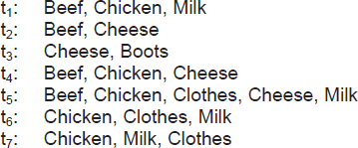
Given the user-specified minsup = 30% and minconf = 80%, you run the Apriori algorithm to find the frequent itemsets and generate rules based on the longest frequent itemsets.

Exercise 2 (Optional): Given the following seven transactions:
Beef, Bread Bread, Clothes
Bread, Clothes, Milk Cheese, Boots
Beef, Bread, Cheese, Shoes Beef, Bread, Cheese, Milk Bread, Milk, Clothes
and MIS(Milk) = 50%, MIS(Bread) = 70%, and 25% for all other items. Again, the support difference constraint is not used. You run the Apriori algorithm to find the frequent itemsets.

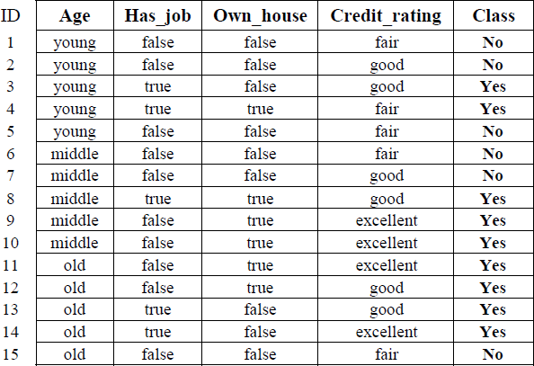
Exercise 3. A loan application data set
Use C4.5 Algorithm with information gain to build decision tree, and generate the rules based on the decision tree.

Exercise 4. Given the confusion matrix as below:
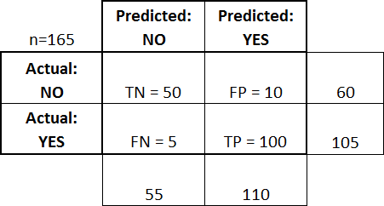
Calculate accuracy, misclassification rate, true positive rate, false positive rate, true negative rate, precision, recall, sensitive, specificity, prevalence.

Exercise 5. Given the data as below with play as classification attribute:

No. | outlook temperature | humidity | windy | play
1 | sunny 85.0 | 85.0 | FALSE | no
2 | sunny 80.0 | 90.0 | TRUE | no
3 | overcast 83.0 | 86.0 | FALSE | yes
4 | rainy 70.0 | 96.0 | FALSE | yes
5 | rainy 68.0 | 80.0 | FALSE | yes
6 | rainy 65.0 | 70.0 | TRUE | no
7 | overcast 64.0 | 65.0 | TRUE | yes
8 | sunny 72.0 | 95.0 | FALSE | no
9 | sunny 69.0 | 70.0 | FALSE | yes
10 | rainy 75.0 | 80.0 | FALSE | yes
11 | sunny 75.0 | 70.0 | TRUE | yes
12 | overcast 72.0 | 90.0 | TRUE | yes
13 | overcast 81.0 | 75.0 | FALSE | yes
14 | rainy 71.0 | 91.0 | TRUE | no
For Decision List as below:
outlook = overcast: yes windy = TRUE: no outlook = sunny: no otherwise: yes
Build the confusion matrix, and calculate the accuracy, precision, recall, sensitive, specificity, f1-score.
Exercise 6. Given the data point set as below:
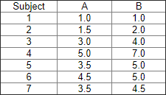
Run k-means (with initial k=2 at subject 1 (1.0, 1.0), 4 (5.0, 7.0)) with Euclidean distance function.

Exercise 7. Given data points as below:
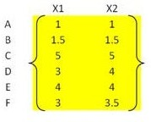
Run hierarchical clustering with Euclidean distance function and single linkage metric between two clusters. Draw hierarchical graph.

